**COMP2211 Deliverable 3 - Project Envisioning Report Group 23**

Andrew Sansum (ajs2g20@soton.ac.uk)

Patrik-Tibor Csanyi (ptc1g20@soton.ac.uk)

Guillaume Comet-Vernet (gcv1u20@soton.ac.uk)

Madhav Muralikrishnan (mkm1g20@soton.ac.uk)

Adam Clarke (ac4g20@soton.ac.uk)

David Stefanov (ds1u20@soton.ac.uk)

**Introduction**

In the third and final sprint we focused on finishing the remaining tasks to the best of our abilities as well as adding some extensions and polishing our final product, so it is more user friendly. The version we submitted at the end of this increment is functional without any known bugs or errors and is user friendly. We also did our best to create a pleasant looking user interface, although it is still quite simplistic, and rough around the edges.

**UML Diagrams**

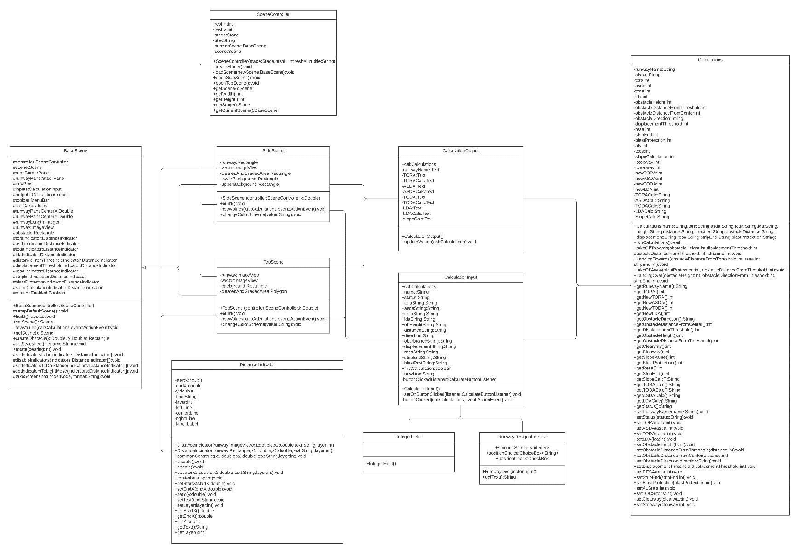1.Class diagrams

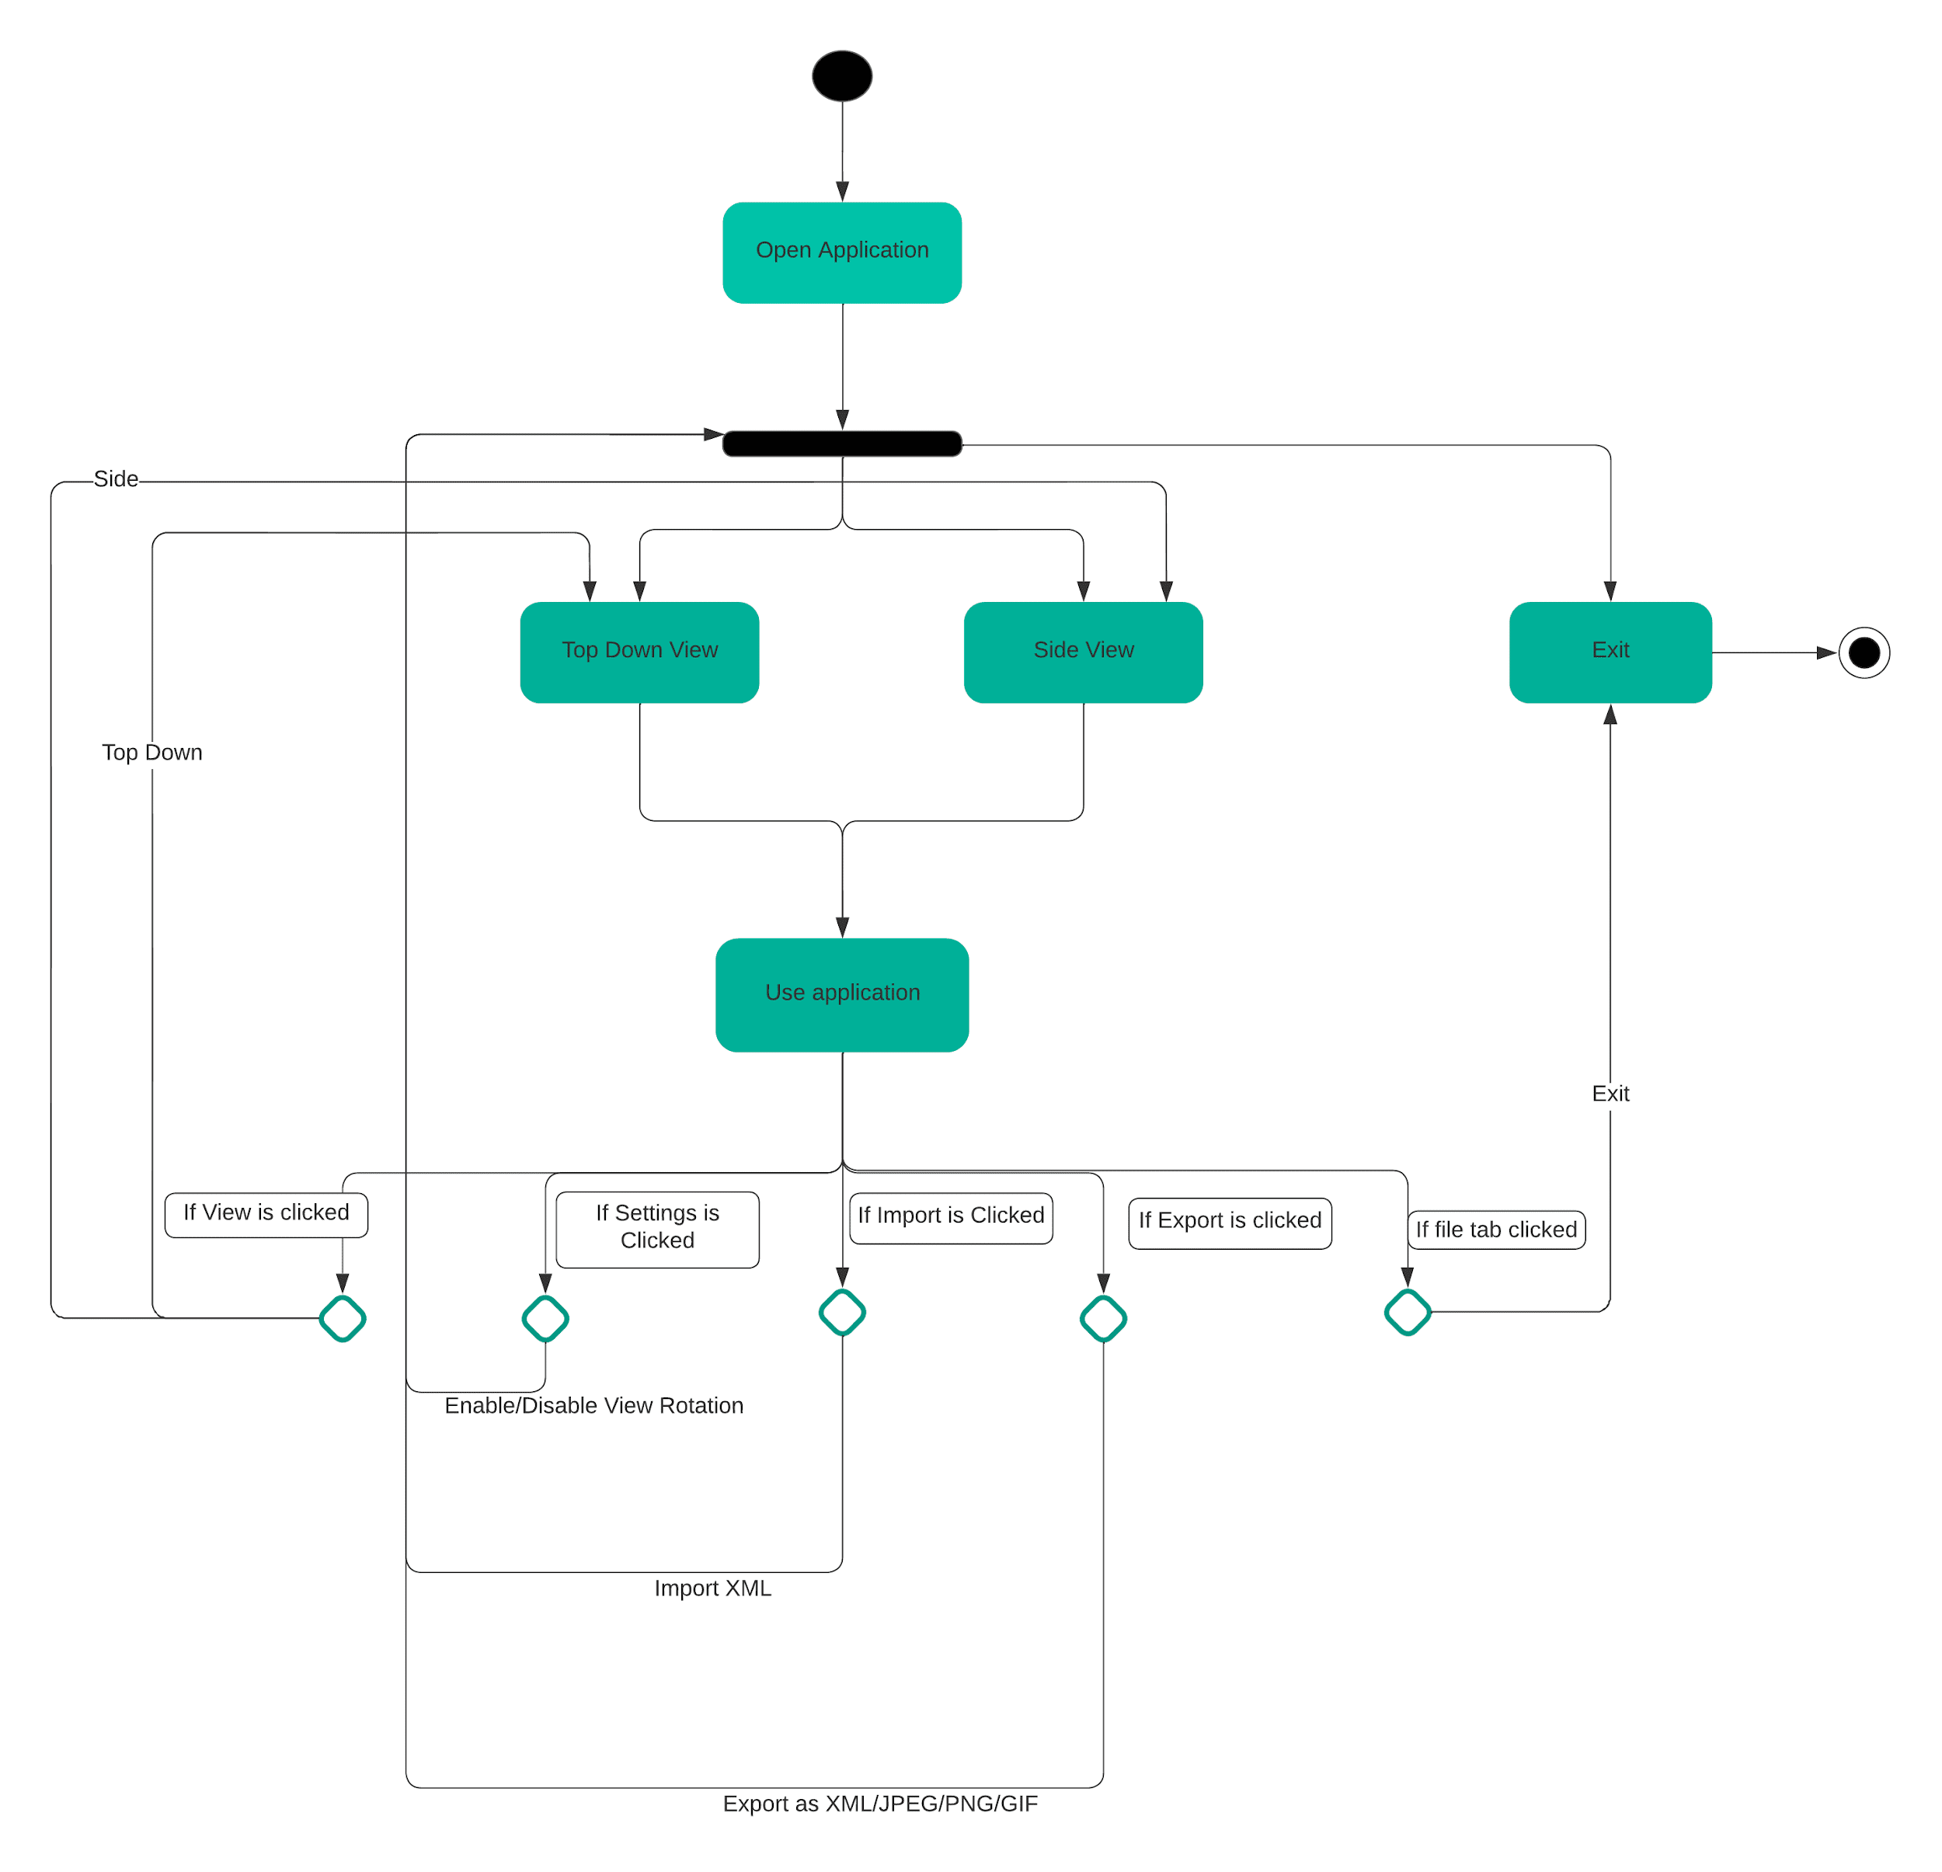2.Activity Diagram

**Logbook**

Feedback after the review:

During the review we received feedback on many different aspects of our submission. Regarding the diagrams we were advised to submit it in a more readable format, as the screenshot could not be zoomed into. Furthermore, we were advised to add indicators to the diagram that describes the relation between classes. Namely whether they have one to one, one to many or some other type of relation.

We were also advised to change our approach from satisfying requirements then testing our code, to test driven development. Not having “writing the tests” as a separate task but including it within each task. We were also advised to include further tests that demonstrated that we finished each user story. While we did do regression testing, we forgot to mention it, and so we were advised to mention it more explicitly.

In terms of our display, we were advised to polish the rotation, as it did not look professional, and the text at times was not readable due to the rotation. We were also advised to change the colour of the text, as on occasion it was not readable due to the blue background. A further problem with the text was that they sometimes overlapped and were not fully visible. We were also advised to leave more space between the indicators and to add an option to disable runway rotation, which we did implement promptly. Further advice was to save the values introduced, so that the user does not have to re-enter them when changing views. Finally, we were advised to remove the landing/taking off choice box and to just display both.

In terms of our calculations, we were advised to extend the breakdown of the calculations and to display what each value represents, not just assume the user will understand.

Informal Review

A few days before our submission, we asked our supervisor to give us some informal feedback. The main points of the feedback were as follows:

Firstly, he reiterated the points we have still not implemented, but he also recommended that we add a textbox that displays the view, runway number and position to make it clearer what the user is viewing.

**Scenarios**

1. **Jaden - aerodrome controller**

* Jaden opens the runway redeclaration app
* Jaden chooses the “Top View” from the “View” toolbar
* A top-down view page is displayed
* Jaden enters the values of a runway with an obstacle
* He accidently enters the value of LDA to be larger than the TORA
* After pressing the Calculate button alert pops saying “LDA cannot exceed TORA”

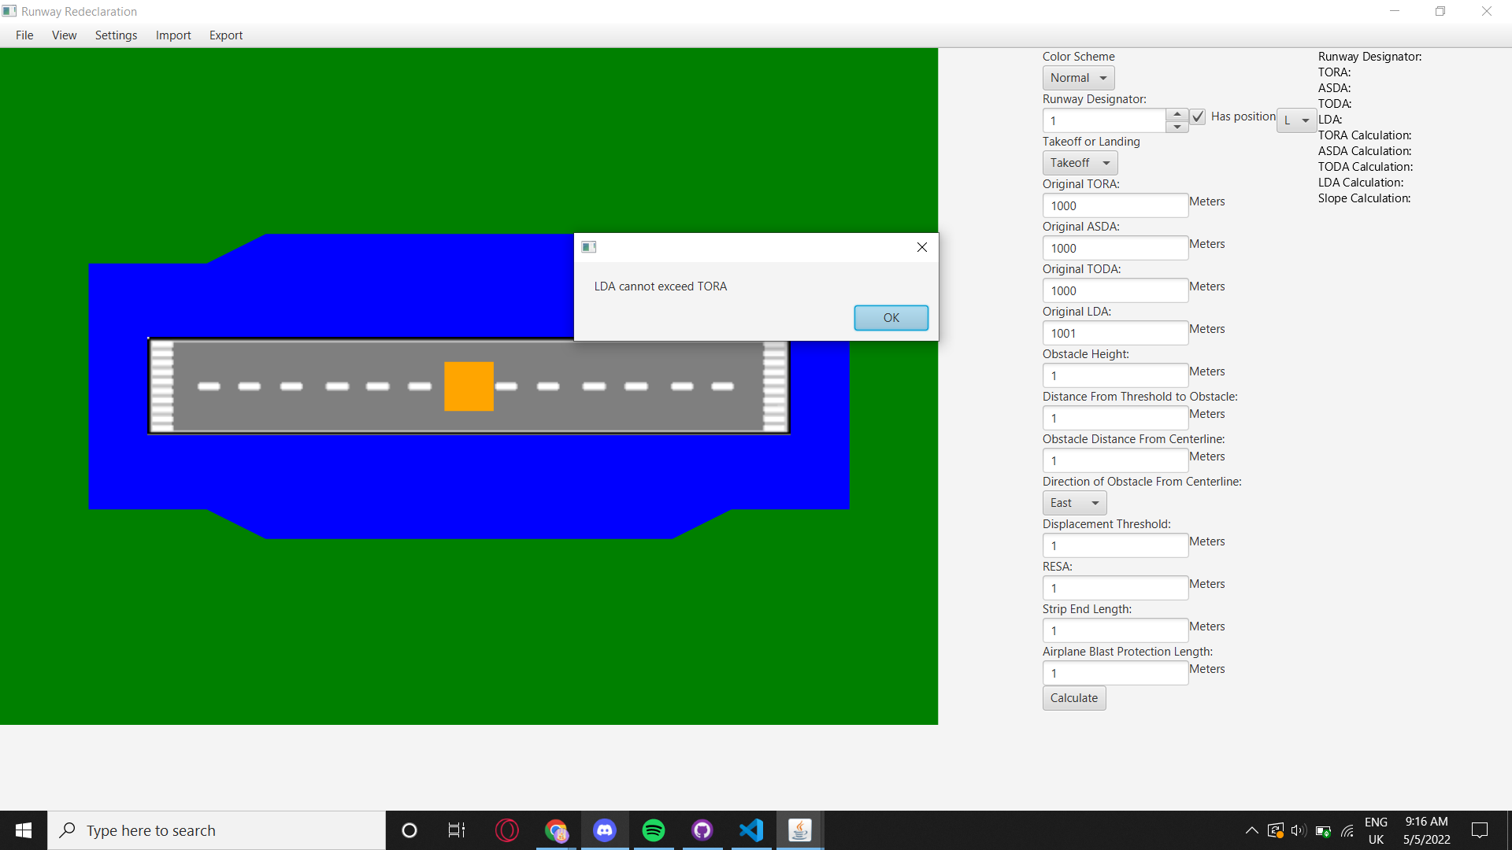

* He re-enters the correct value
* He presses the Calculate button
* Jaden sees exact top-down visualization of the runway

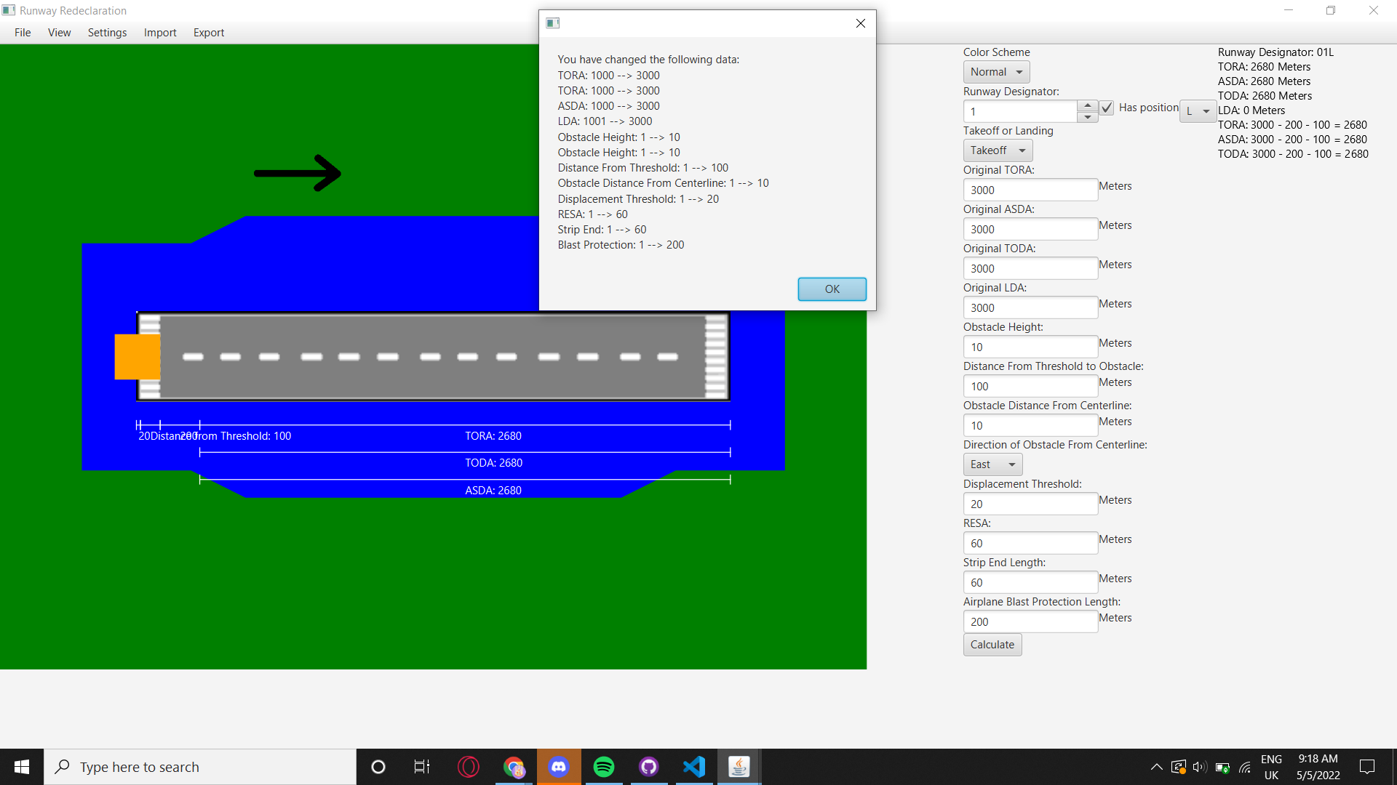

* Jaden clicks “View” at the toolbar and then clicks “Side View”
* A side view page is displayed
* Jaden once again enters the same correct values
* A side view of the runway is visualized
* The indicators show the exact values of the runway
* Jaden clicks “View” and then chooses “Top and Side View”
* A screen split into side view on the left and top view on the right is displayed

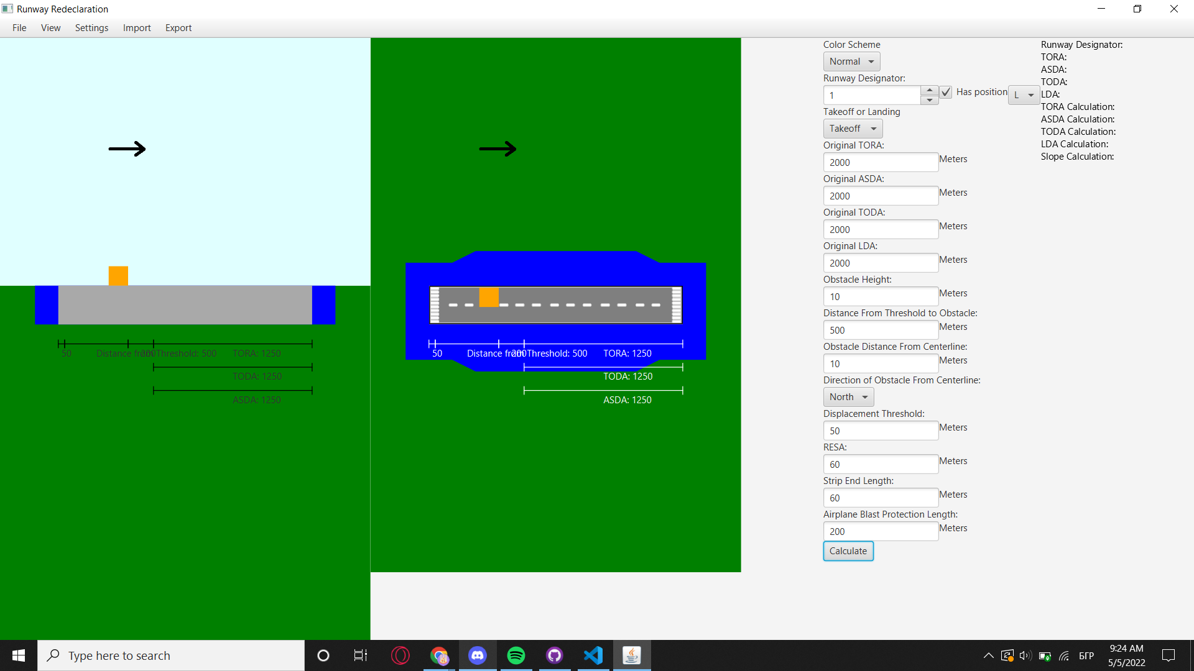

1. **Jane - approach controller**

* Jane opens the runway redeclaration app
* Jane chooses the “Side View” from the “View” toolbar
* A side view page is displayed
* Jane clicks on the drop-down menu under “Colour Scheme” and chooses “Dark”
* The colour scheme of the application becomes dark
* Jane enters the values of a runway with an obstacle
* She presses the Calculate button
* Jane sees how much of the runway is usable and in what direction is the plane coming/going

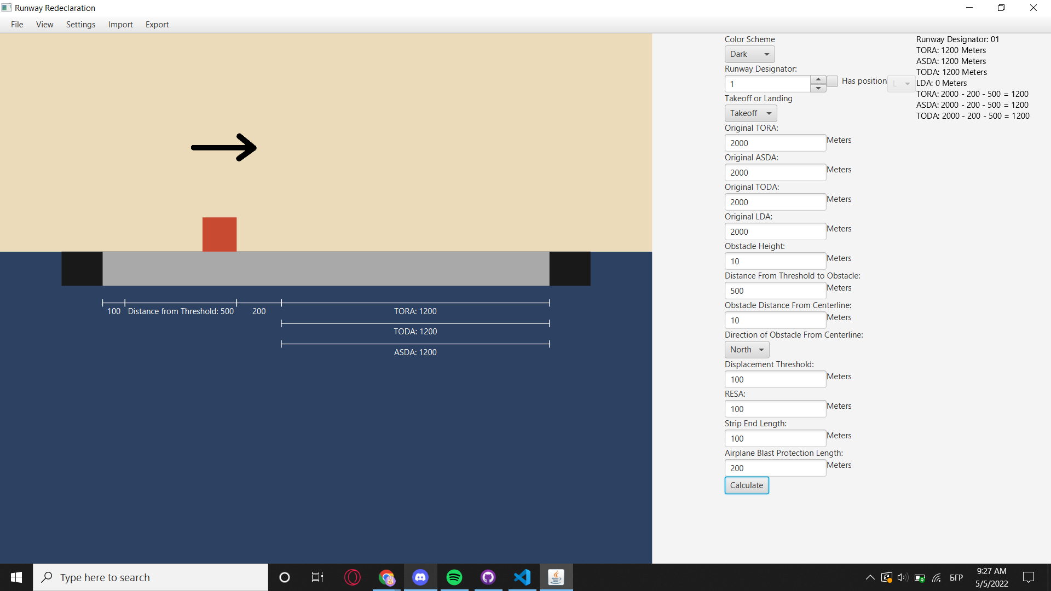

1. **Gemma - independent calculator**

* Gemma opens the runway redeclaration app
* Gemma selects “View” from the toolbar and then chooses “Side View”
* A side view page is displayed
* Gemma enters the values of a runway with an obstacle
* She presses the Calculate button
* Gemma checks all the newly displayed values
* Jemma clicks on “Export” and then chooses “Export as JPEG”
* Jemma chooses a directory where to save the picture of the side view plus the entered values and results on the left.

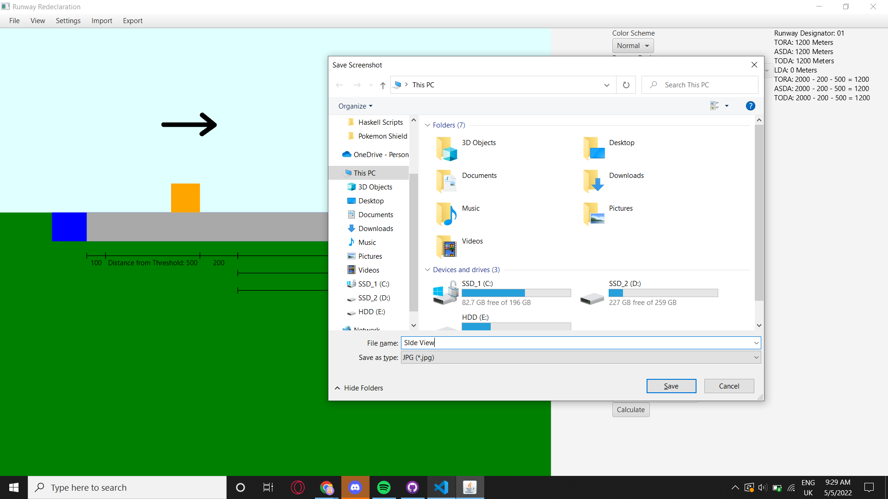

* Gemma selects “View” from the toolbar and then chooses “Top View”
* Gemma clicks on “Settings” and then on “Enable View Rotation”
* After entering the values and pressing “Calculate” the view rotates according to value chosen from the drop down menu under “Direction of Obstacle From Centreline”

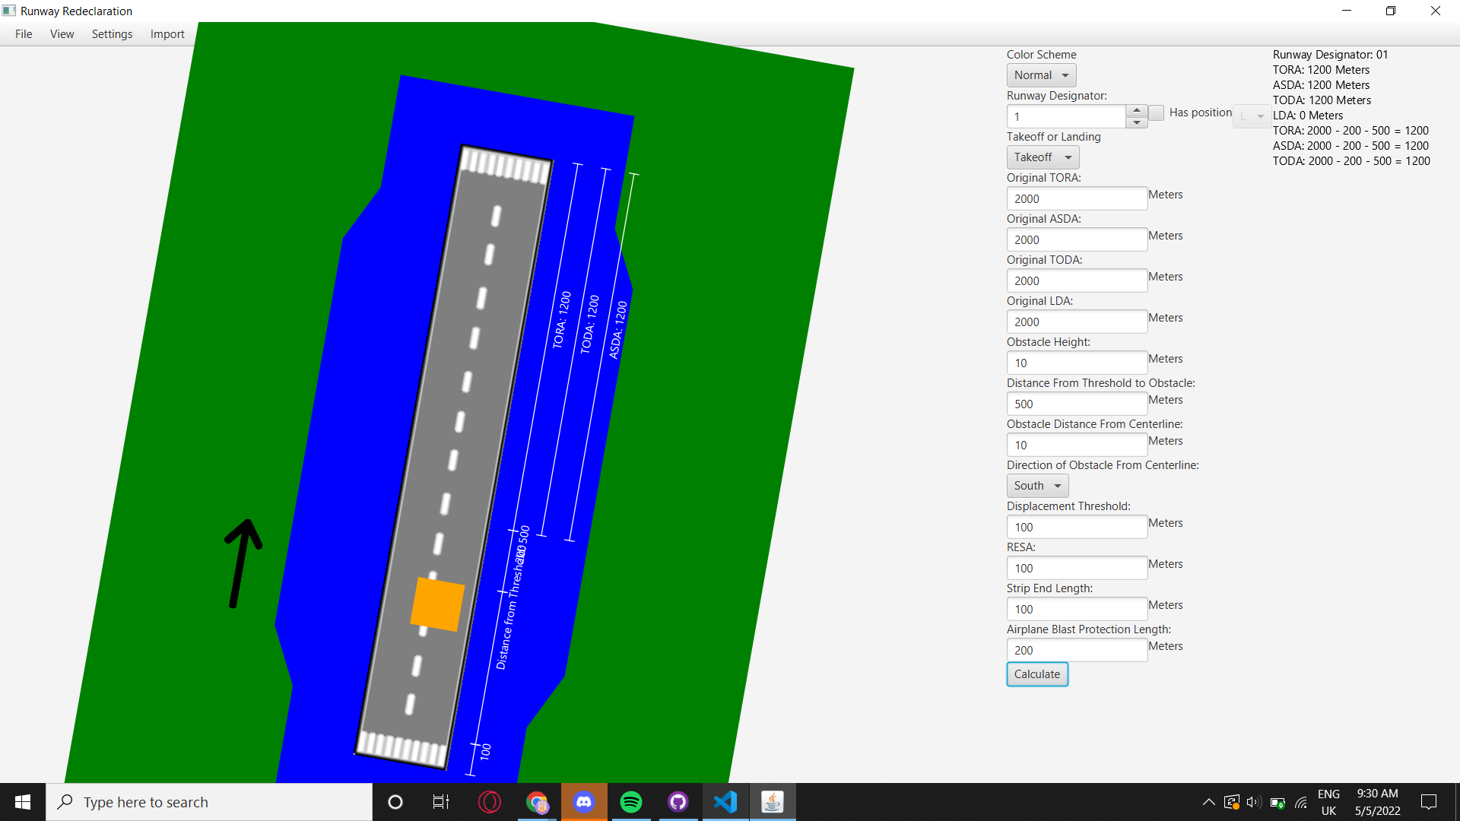

* Gemma clicks on “Settings” and then on “Disable View Rotation”
* Gemma presses “Calculate” once more, and the view is displayed normally

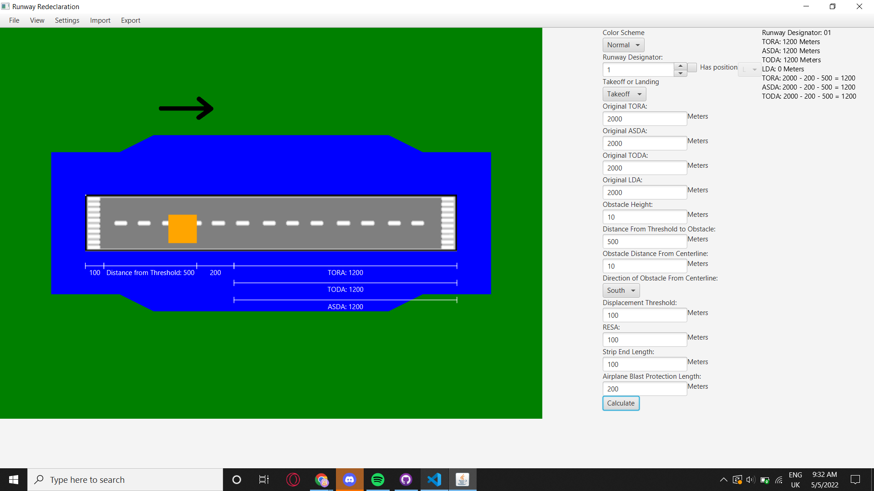

* Gemma clicks on “Export” from the toolbar and then chooses “Export as XML”
* Gemma chooses directory and name of the file and saves it
* Gemma clicks on “Import” and then chooses “Import XML”
* Gemma chooses a file from the file explorer and clicks it
* New Values are loaded from the file
* Gemma presses “Calculate” and sees the view of the loaded runway
* Gemma clicks “File” at the toolbar and then exit
* The application closes

**Storyboards**

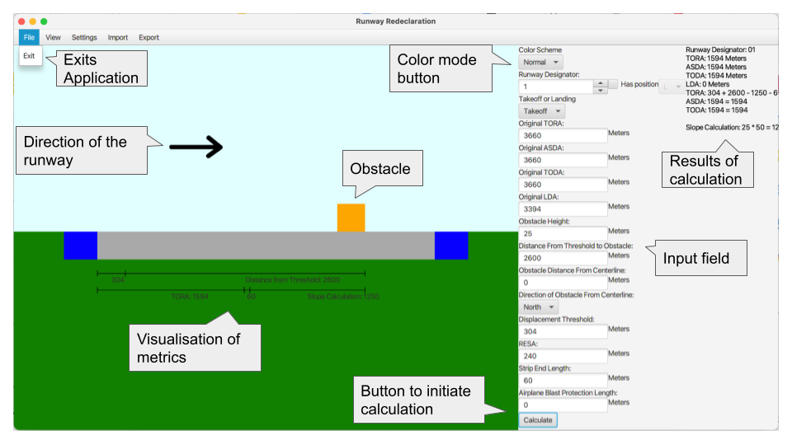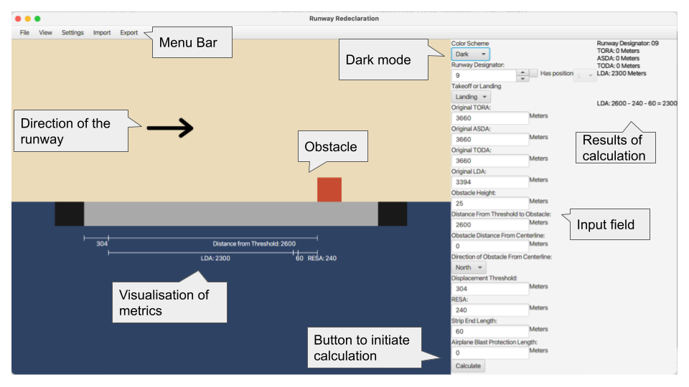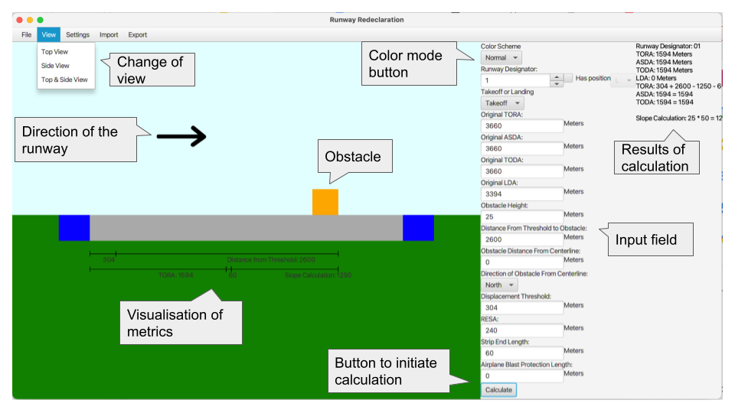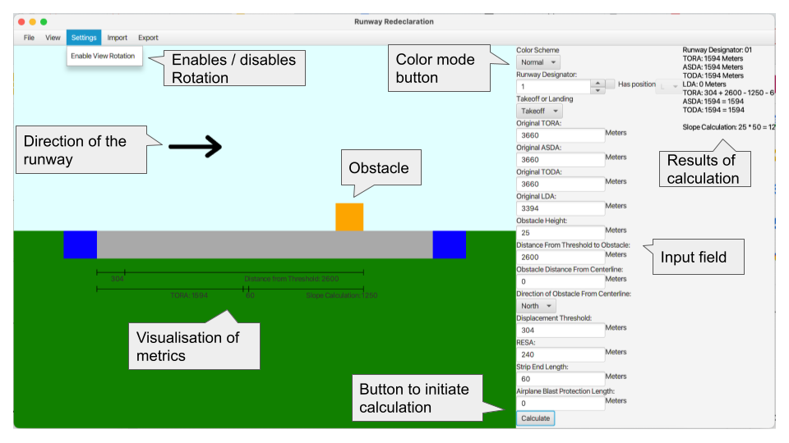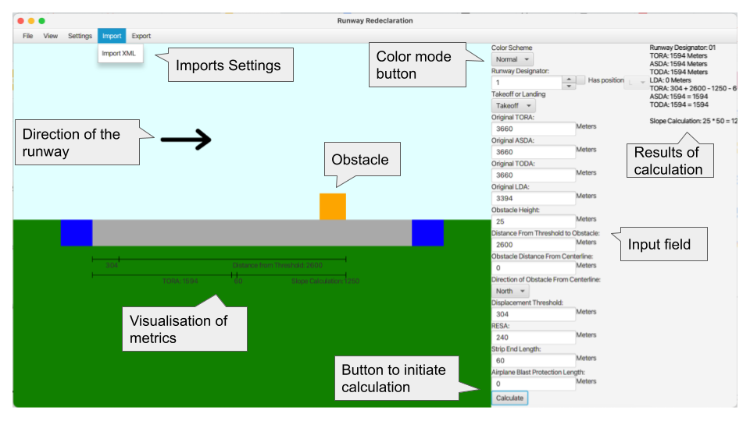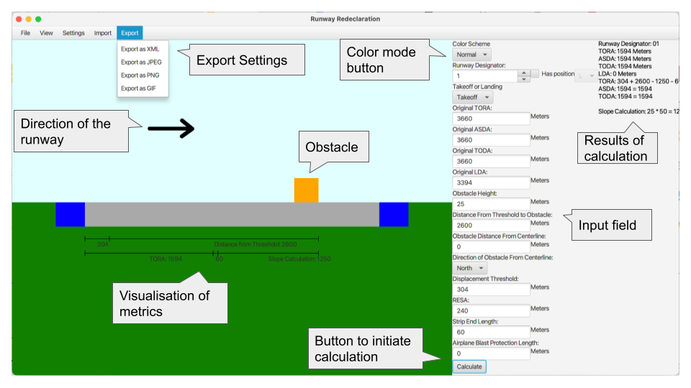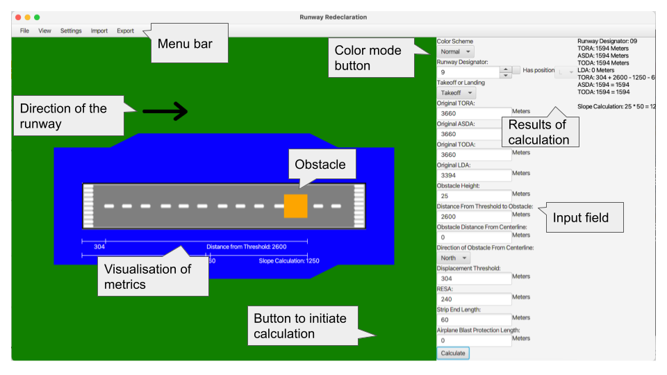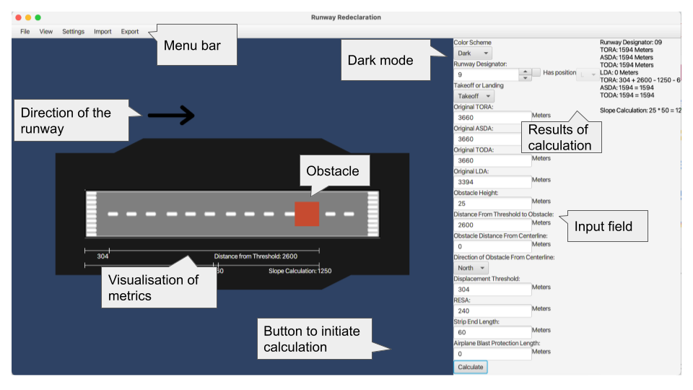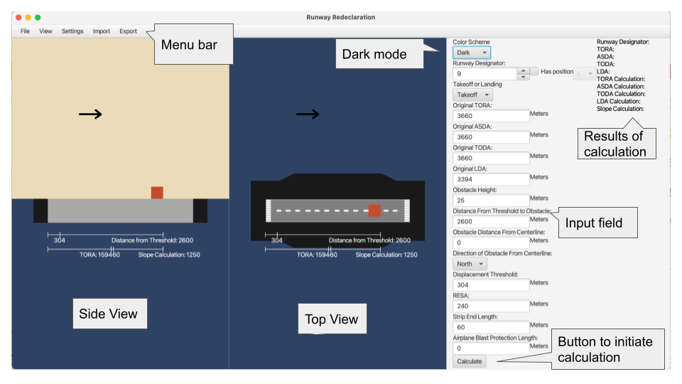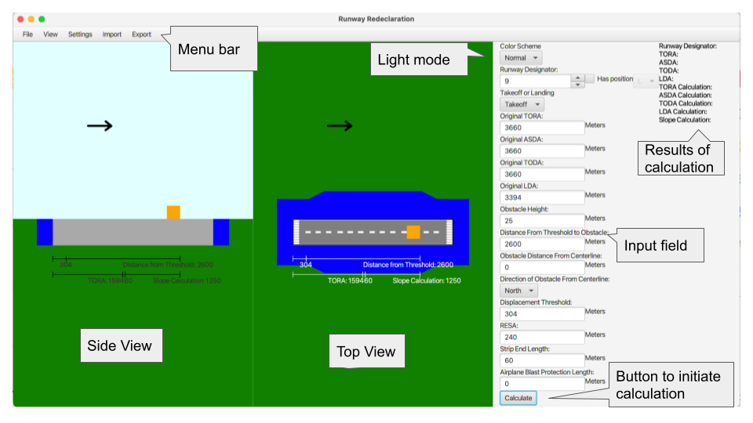

**Backlog**

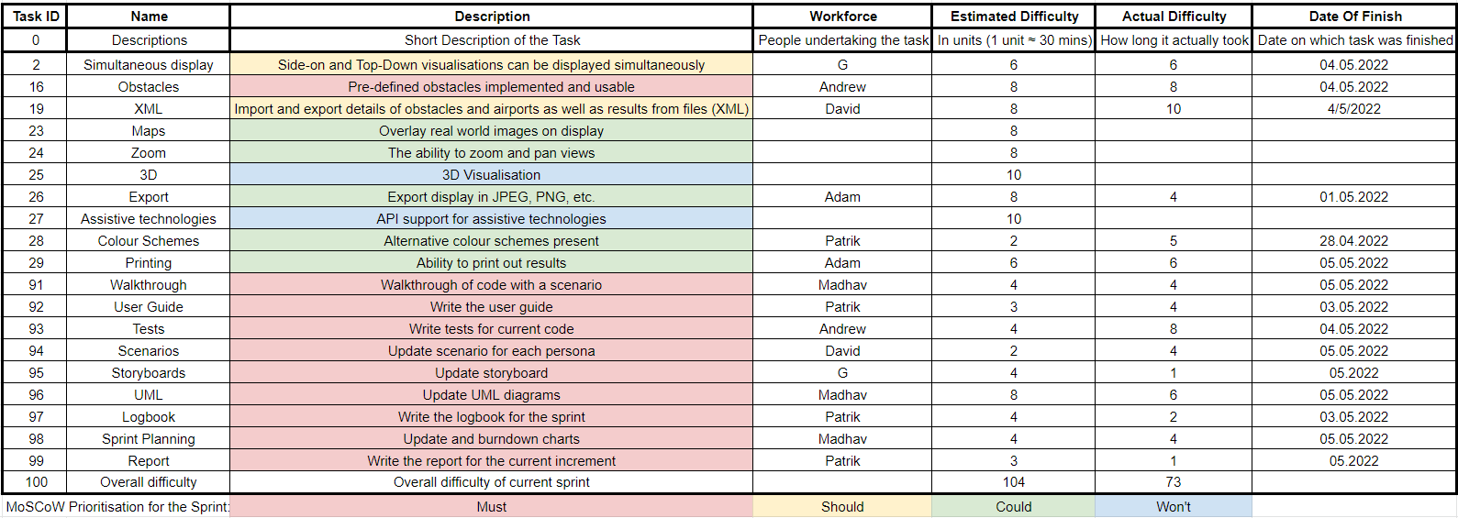Third Sprint Backlog:

**Burndown Charts**

Third Sprint burndown chart: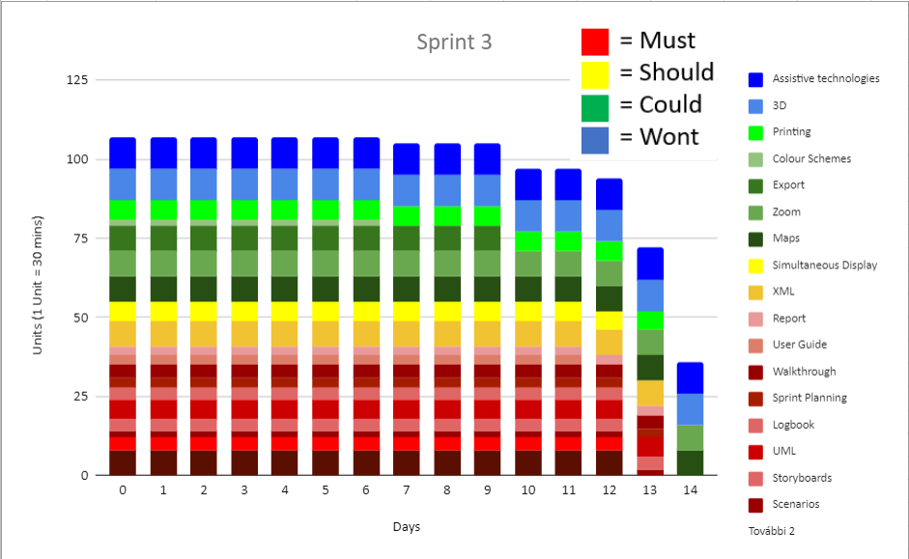

**Tests**

### Pre-calculation Input Value Ranges:

Ranges for the numeric parameters before calculations are as follows:

|  |  |  |
| --- | --- | --- |
| ***Parameter*** | ***Lower Bound*** | ***Upper Bound*** |
| **TORA** | 0 | -- |
| **ASDA** | 0 | -- |
| **TODA** | TORA | -- |
| **LDA** | 0 | TORA  (inclusive bound) |
| **Obstacle Height** | 0 | -- |
| **Obstacle Distance from Threshold** | -- | -- |
| **Threshold Displacement** | 0 | TORA |
| **RESA** | 240 | TORA |
| **Strip End** | 60 | TORA |
| **Blast Protection** | 0 | TORA |

NOTE: Lower bounds are inclusive and upper bounds are exclusive unless otherwise specified.

The only non-numeric parameter is Status which must be either of the strings “Landing” or “Takeoff”.

Tests will assert that the class throws an exception on values out of these ranges and that no exception is thrown on valid ones. Partitions for these tests will be erroneous values from outside the ranges, border values on the ranges, and regular values from within the ranges.

### Calculation Cases:

There are four major cases for calculations:

* Landing over the obstacle
* Landing towards the obstacle
* Takeoff towards the obstacle
* Takeoff away from the obstacle

The diagram below illustrates the logic behind choosing a case:

Is the obstacle more than halfway away from the threshold towards the end of the runway?

What is the value of status?

What is the value of status?

Landing Towards

Takeoff Towards

Landing Over

Takeoff Away

Yes

No

Landing

Landing

Takeoff

Takeoff

Tests will ensure that the calculations chooses the correct case based on its parameters. The cases can be differentiated through the results of the calculations. Values changed for each case will be the ‘object distance from threshold’ and ‘status’.

|  |  |  |
| --- | --- | --- |
| **Object Distance** | **Status** | **Expected Case Chosen** |
| -50 | Landing | Landing Over |
| 100 | Landing | Landing Over |
| 1800 | Landing | Landing Over |
| 3500 | Landing | Landing Towards |
| 3700 | Landing | Landing Towards |
| -50 | Takeoff | Takeoff Away |
| 100 | Takeoff | Takeoff Away |
| 1800 | Takeoff | Takeoff Away |
| 3500 | Takeoff | Takeoff Towards |
| 3700 | Takeoff | Takeoff Towards |

NOTE: The assumed TORA here is 3600 i.e. the halfway point is 1800

### Results Bounds:

For all four declared distances (TORA, TODA, ASDA and LDA), the respective redeclared distances may exceed the original. In the case that they do, the original should be returned instead.

Redeclared distances exceeding the original are usually a result of the absolute value of the obstacle distance being large. It is intended behaviour that the obstacle does not have to be on the runway. How this affects calculations is different for each of the four major cases.

#### Landing Over:

In this case we calculate the LDA with:

With this, if the obstacle distance is negative and then the new LDA will be larger. Cases to test here are:



#### Landing Towards:

In this case, we calculate LDA with:

As we are landing towards, we know the obstacle distance is positive and larger than half the TORA. If then the new LDA will be larger. Cases to test here are:

#### Takeoff Towards:

In this case, we calculate TORA with:

New ASDA and TODA simply return the new TORA. Similar to landing over, if the obstacle distance is negative and then the new TORA will be larger. Cases to test here are:

#### Takeoff Away:

Calculations for this case are:

With this, if the obstacle distance is negative and then the new values will all be larger. Cases to test here are:



### Cases regarding height and blast protection

There are cases in landing over and taking off towards that rely on comparing RESA and the height. Landing over is also dependent on comparing the blast protection.

#### Landing Over

The calculation for landing over the obstacle is as follows:

where . See diagram below.

RESA

Obstacle height * 50

Maximum of

**+**

Strip End

Blast Protection

Maximum of

This gives four test scenarios from the two choices (h * 50 vs. RESA and then RESA + Strip end vs. Blast Protection).

#### Taking Off Towards

The cases for taking off towards only take the h*50 vs. RESA choice into account, therefore there are only two test cases.